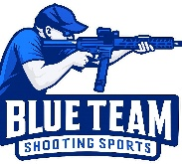
Blue Team Shooting Sports A.S.S.S. May 26th. 2026
COURSE DESIGNER: Ike Starnes

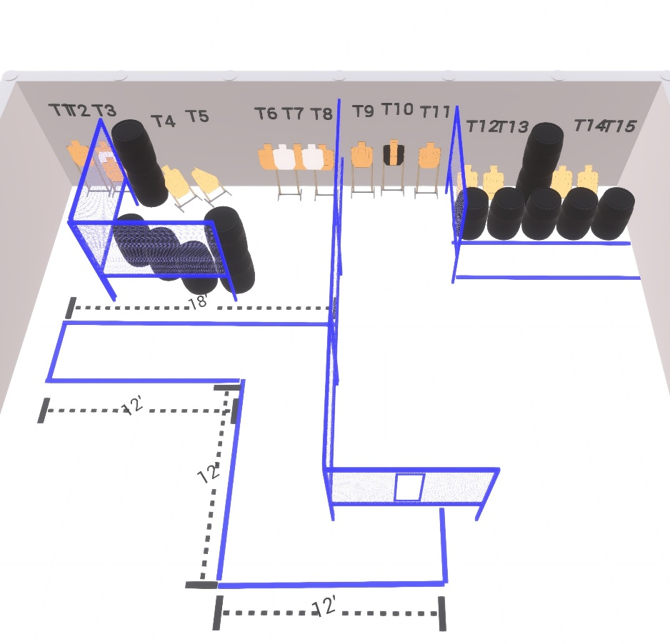

Written Stage Briefings:

Stage 2 – Survival Mode - is a 30-round, 60 point, Comstock Course. There are 15 cardboard targets and some noshoots.
Handgun start position Anywhere. The handgun is loaded and holstered.
PCC start position Anywhere. PCC is loaded with stock touching belt.
On the audible start signal, engage targets from within the shooting area.

